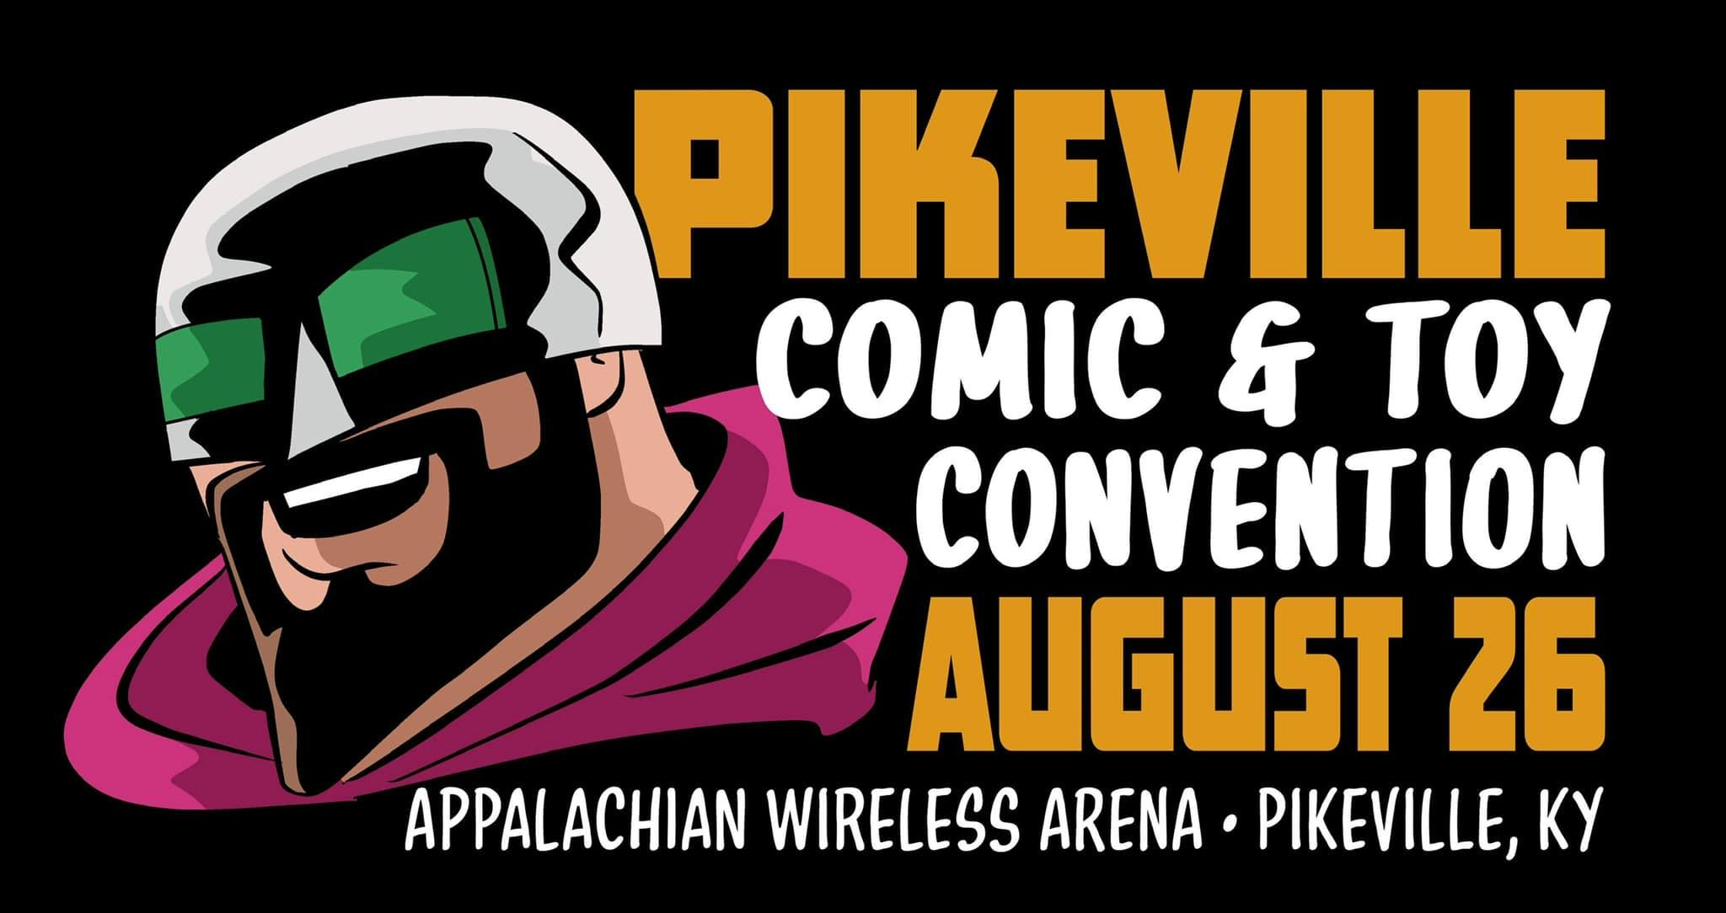
Exhibitor/Vendor Registration
JUNE 1, 2024/ 9am to 6pm
Pikeville Comic & Toy Convention
204 Glynview Plaza
Prestonsburg, KY. 41653
www.pikevillecomiccon.net
facebook.com/pikevillecomiccon

Exhibitor Name (as it will appear on the website): ________________________________

Contact Name: ___________________________________________________________

Address: ________________________________________________________________

City: _________________________________ State: ______ Zip: __________________

Phone: _______________________ Email: _____________________________________

Website: ________________________________________________________________

Vendor Tables _____ x $130/booth: = ______________

Exhibitor/ Artist Tables ______ x $75/booth = _______

If you have a logo and/or bio please email it to pikevillcomiccon@gmail.com so we can add it to the website and Facebook.

Booth Space: Booths are 8x10 with one 8ft table and two chairs and two badges.
PAYMENT: Please make checks/money orders payable to Kent Leedy

CANCELLATIONS:
No refunds will be given after APRIL 30,2024

ELECTRIC can be provided by the arena. The cost is $35 plus tax. This is the exact cost.

Adult Material
In an effort to promote and maintain a family friendly atmosphere, the Pikeville Comic Con requests that adult material not be prominently displayed, and that vendors and exhibitors verify the age of anyone purchasing said materials.
Bootlegs
Pikeville Comic Con does not allow the sale of “pirated” or “bootleg” merchandise. Please do not display or sell these items. Doing so terminates this vendor’s agreement and no refunds will be issued.
Set-up/Tear Down
Each exhibitor/vendor is responsible for their own load in (starting at 12pm Friday May 31, 2024) and load out. By signing this you also agree not to tear down your exhibit until after 6pm on JUNE 1,2024.

Hold Harmless
By agreeing to be an exhibitor or vendor at the Pikeville Comic Con, you agree to protect, keep and save the Pikeville Comic Con and any other agents forever harmless from any damages, loss, theft, cost, liability, act of God, terrorism or expense that arises from exhibiting at this convention. This agreement covers full setup, run, tear down, and exit of show. By signing below you are indicating your approval of all information contained.

Name and Date (Print): ____________________________________________________

Signature: _______________________________________________________________

Mail Check and Registration Form To:
The eStore Comic & Tech Shop
204 Glynview Plaza
Prestonsburg, KY. 41653

